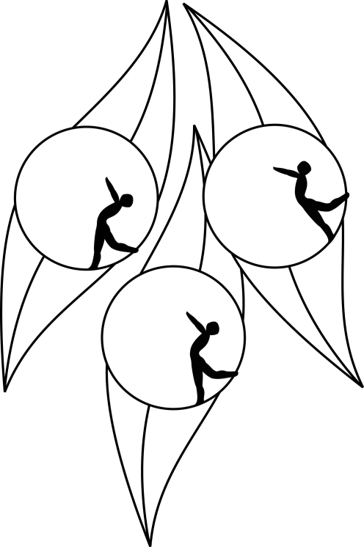
SOUTH AUSTRALIAN ICE SKATING ASSOCIATION Inc.

RESULTS

TEST SESSION

17 November 2011
Ice Arena, Thebarton

Congratulation to the following skaters:

Primary Ladies
Arielle Jennings

Pre-Primary Technical
Alyce Naylor

Pre-Primary Dance
Callum Bradshaw

